
MR. THIHA AUNG

PRODUCTION & MAINTENANCE ENGINEER

Profile
Contact
Blk 425 #06-158, Chua Chu Kang Ave4, S 680425 SINGAPORE

thiha2022th.th@gmail.com

+6583814877 (WhatsApp)


Ambitious professional with a Bachelor's Degree in Mechanical Engineering and 5 years of experiences as production and maintenance field with partial and technical knowledge in this my experiences. I can contribute to company growth and seek new opportunities to enhance my knowledge.




Personal Info
Professional Experience
DOB 28/07/1994
Passport No ME838704
Nationality Myanmar
Material Status Single
Availability Immediate
Expected salary 2500(Nego;)

Production & Maintenance Engineer May2022 to June 2023
Commercial Plastic Co., ltd Yangon, Myanmar
Duties and Responsibilities
- Supervise and manage plastic recycling operations to achieve production targets, quality standards, and cost efficiency.
- Identify opportunities for process improvement and implement measures to enhance recycling productivity and reduce waste.
- Develop and execute comprehensive maintenance plans and schedules for all recycling equipment and machinery.
- Lead and participate in troubleshooting efforts to diagnose and resolve equipment breakdowns and malfunctions promptly.
- Implement preventive maintenance procedures to minimize equipment downtime and extend the life of critical recycling assets.
- Ensure to safety operation and during maintenance activities to safeguard and recycling assets.
- Compliance with safety and environmental regulations in all recycling activities.

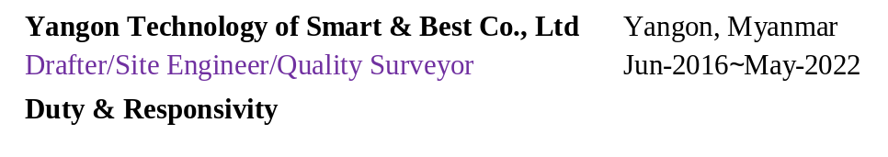

9

Professional Skills
- Able to work under pressure
- Time management
- Communication and teamwork
- problem-solving
- Good at time management
- Interpersonal skill
- Methodical way of thinking

Production & Maintenance Engineer Oct 2018 to May 2022
Aventine Co., ltd (Armo Fertilizer) Yangon, Myanmar
Duties and Responsibilities,
- Daily checks and need to repairs on essential equipment, including Elevator motors and Air compressors before production to guarantee optimal functioning.
- Manage production workers, documentation processes for operations and to reduce machine downtime for Preventive maintenance procedures.

Academic background d

Technological University (Yangon)
- Bachelor of Engineering
Mechanical (2019)

- Bachelor of Technology
Mechanical (2016)

- English (Upper-Intermediate)
- Burmese (Native)
- Chinese (Basic)

Language
- Optimize production workflows to ensure timely launch of new fertilizer products and maintain high productivity levels
- Safety regulations are in operation area and sustainable work environment.
- Properly maintain and clean semi-auto bagging machines after production, ensuring they are ready for the next production cycle.
- Supervises the operation and maintenance of various equipment such as weighing machines; sewing machines; underground hoppers and vibrations; undifferentiated machines, bucket lifts and 30-ton overhead crane.

- Manage overall project budget, schedule, scope, deliverables, execution, and follow through to provide the expected benefits of the project.
- Supervision of construction works and co-ordinate with client’s representation, consultants and sub-constructors on technical issues.
- Project requirements to design, integrate, source and implement electrical systems and relevant peripherals to meet projects deliverables on schedule.

Professional Experience

Academic background

Software
- Certificated of AutoCAD
(2D,3D,Isometric course)
- Microsoft Office Work
- Microsoft Office Excel
- ACMV Course
- Safety Supervisor Course

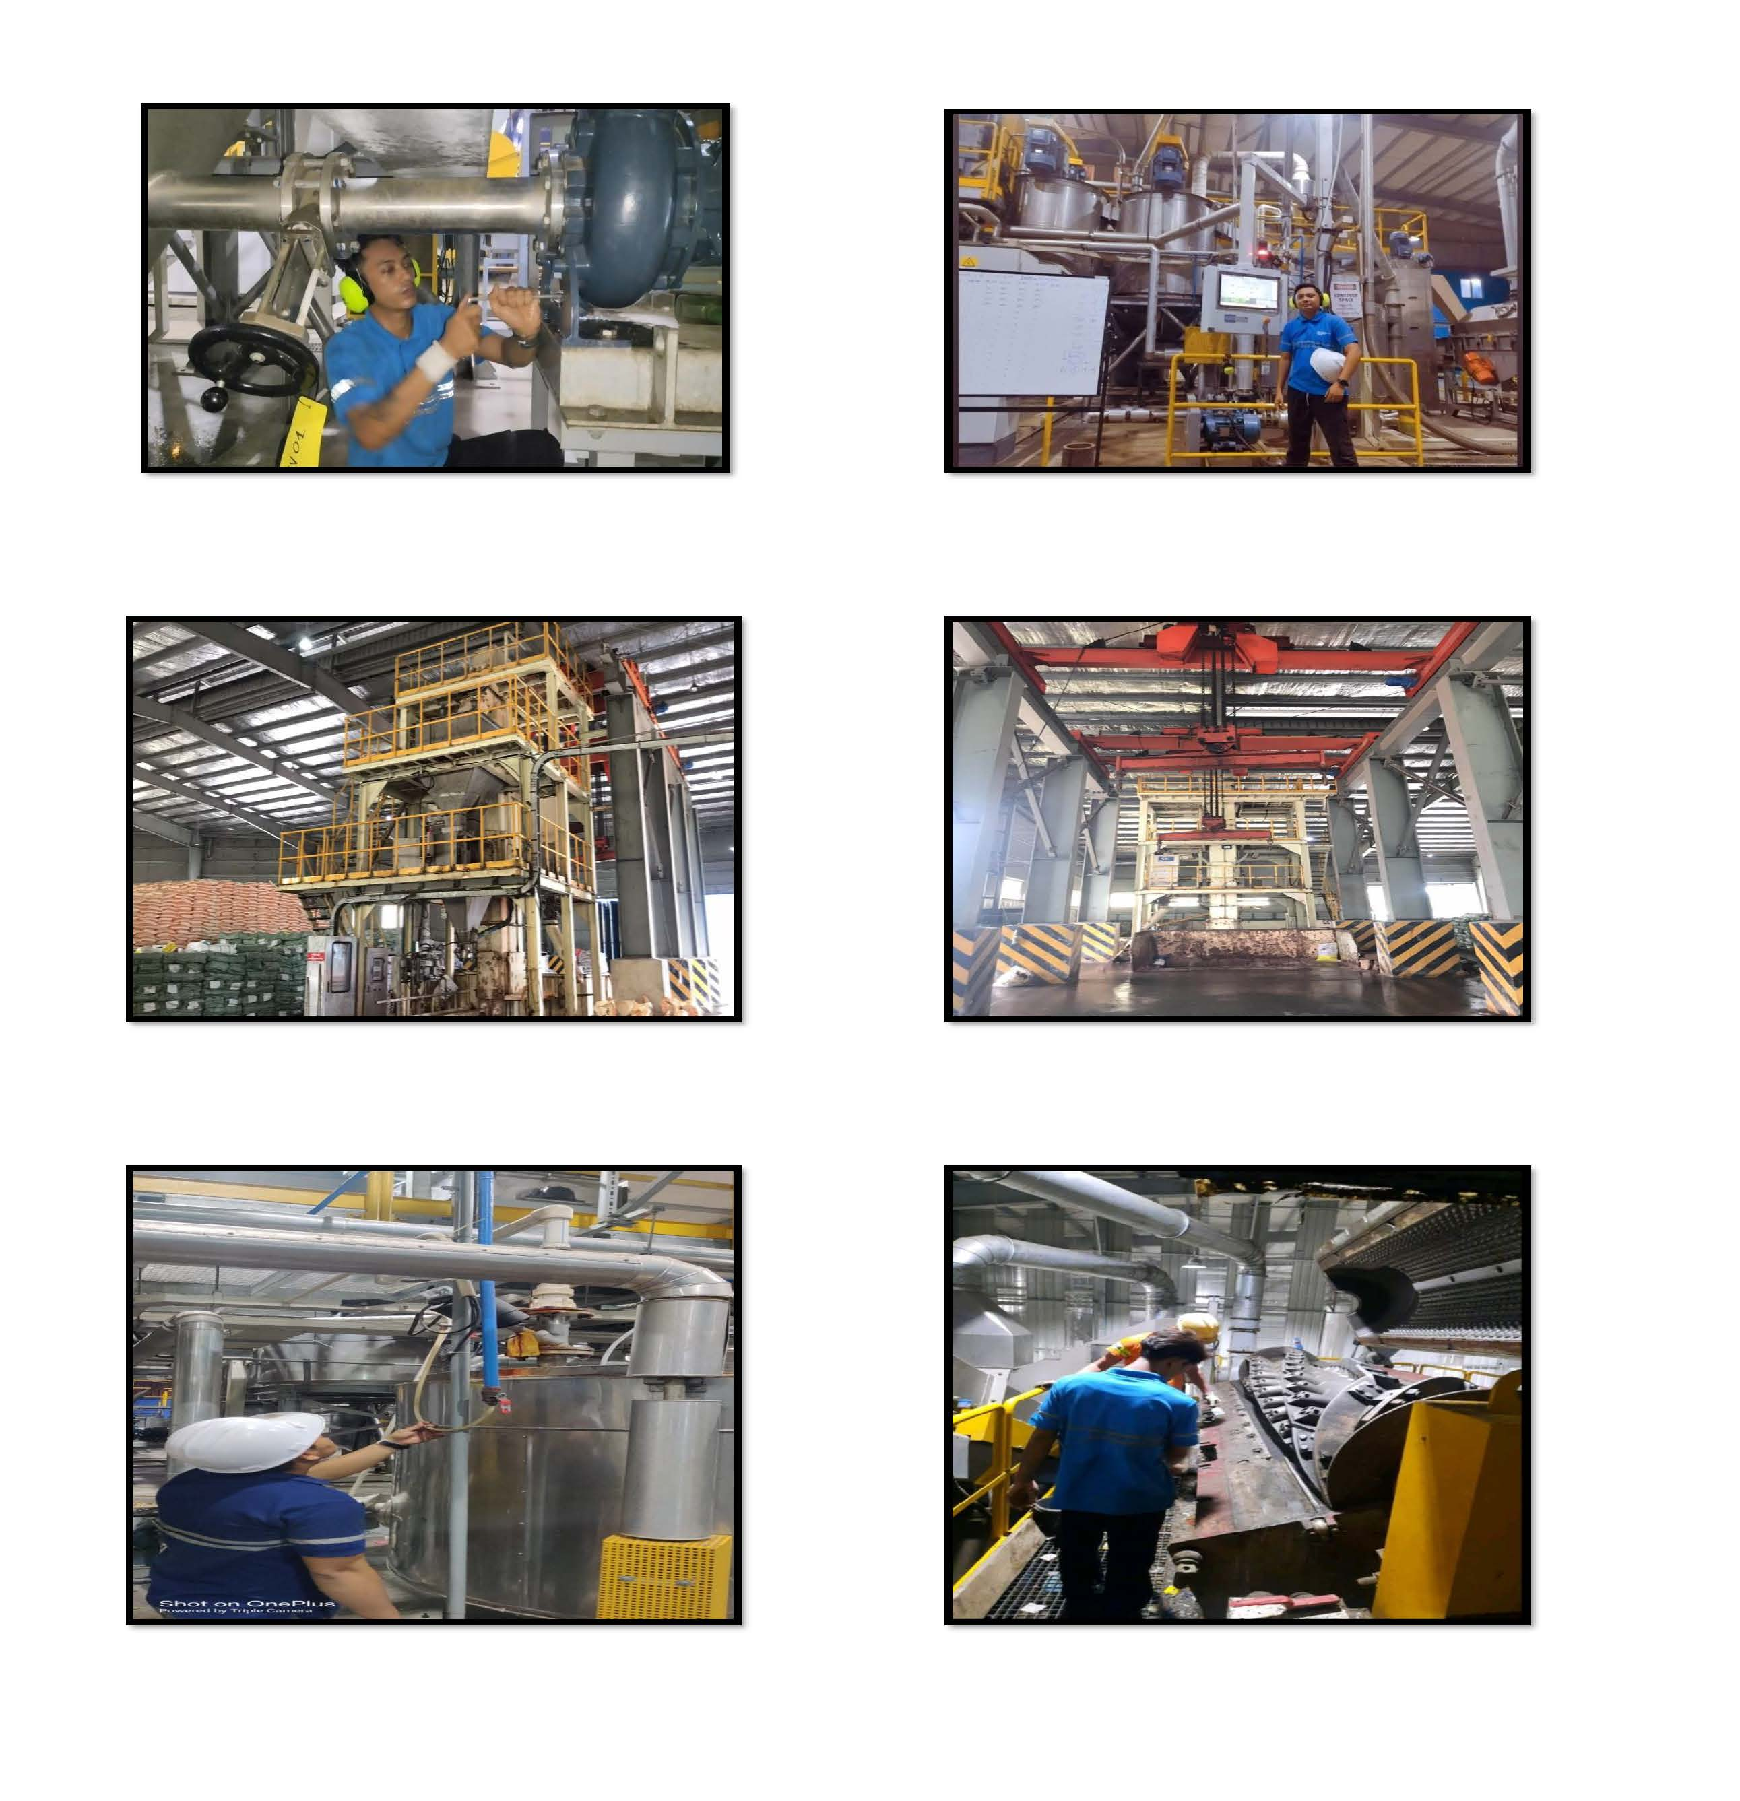
Reference Project

Interests
- Gaming Playing
- Cooking & Food
- Travelling
- Singing
- Volunteering

In front of HMI of the Commercial Plastic Co., Ltd
Impeller Motor maintenance in Commercial Plastic Co., Ltd

Career Goal
Looking for a challenging role in a reputed company to utilize with my over 5 years engineering skills maintenance and production that I can contribute to the company’s growth as well as enhance my knowledge by exploring new things. I do certify that above statement is true and correct for the best of my knowledge.

With Best Regards,
Mr. Thiha Aung

Email : thiha2022th.th@gmail.com

Hp : +6583814877(WhatsApp)

After servicing Overhead crane in Aventine Co., Ltd
Aventine Co., Ltd.’s Fertilizer Bag Packing Machine

Changing all blades in Grinding machine of Commercial Plastic Co., Ltd

Inspection of all machines before production in Commercial Plastic Co., Ltd

